REGISTRATION INFORMATION

Full Name: ______________________________________________________________________________________

***First Last***

Address: _______________________________________________________________________________

***Street Address***

***_____________________________________________________________________________________________________***

***City State Zip Code***

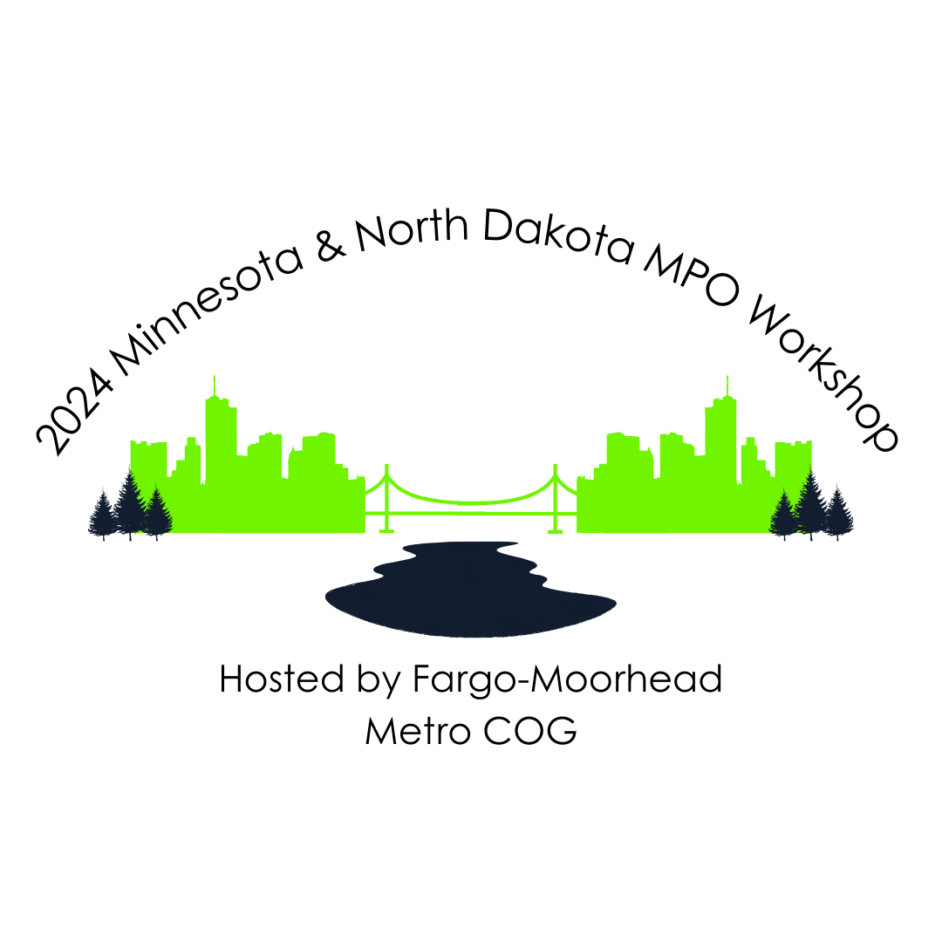

***_____________________________________________________________________________________________________***

***Organization***

Attending (check all that apply):

Tuesday, October 29

__ Afternoon Sessions

Wednesday, October 30

__ All-day Sessions (lunch included)

Thursday, October 31

__ Morning Sessions

CONFERENCE INFORMATION

**Conference Location / Hotel Reservations:**

Radisson Hotel – Downtown Fargo Parking is included in the registration fee

201 5th Street North for October 29- 31

Fargo, ND 58102

A block of rooms has been reserved at the Radisson Hotel

Two Full Beds or King Bed rooms

[Book Online](https://www.fmmetrocog.org/2024MPOWorkshop/hotel) or 701-232-7363 under **“FM Metropolitan Council of Governments”**

_________________________________________________________________________

**Registration Total Cost $160**

**Check Payable to: For Credit Card Payments:**

FM Metro COG Please Contact Angela Brumbaugh

1 – 2nd Street South, Case Plaza #232 at (701)-532-5101 to register

Fargo, ND 58102-4807

Please fill out one form per person